# MID PROJECT REVIEW

**Erection and commissioning of the Rolling Mill, along with spare parts management for Rolling Mill equipment.**

*Submitted by*

**Sumer Bassi**

*Supervisor*

# Mr. Shivam Kharre



Tata Steel Ludhiana, is a landmark project as India’s first low-carbon, green steel plant. This state-of-the-art facility is designed to produce high-quality TMT bars ranging from 8 mm to 40 mm diameter using scrap metal as the primary raw material, processed through advanced Electric Arc Furnace (EAF) technology. The plant is expected to produce 750,000 tons per annum (tpa) of steel, primarily rebar in 550 SD grade.

**Technological Highlights:**

* **Electric Arc Furnace (EAF):** The plant uses a 100% scrap-based EAF, making it highly energy-efficient and significantly reducing carbon emissions compared to traditional blast furnace steelmaking.
* **Continuous Charging System:** The facility employs an advanced Electric Charging System (ECS) for continuous feeding of scrap metal to the furnace, enhancing process efficiency and stability (except for brief intervals of 2–3 minutes).
* **Sustainability:** The plant is designed for a circular economy, recycling steel scrap sourced from Tata Steel’s recycling plant in Rohtak, Haryana, and the local auto hub.
* **Renewable Energy Integration:** The plant is equipped to use renewable energy sources like wind and solar, further reducing its carbon footprint.
* **Advanced Emissions Control:** The facility incorporates modern emissions control and carbon capture technologies to minimize environmental impact.

**References**

1. [Tata Steel Ludhiana steel plant - Global Energy Monitor](https://www.gem.wiki/Tata_Steel_Ludhiana_steel_plant)
2. [Punjab CM Bhagwant Mann lays foundation stone of Tata Steel plant in Ludhiana - The Tribune](https://www.tribuneindia.com/news/ludhiana/cm-lays-foundation-stone-of-tata-steel-plant-555146/)
3. [Punjab CM Shri Bhagwant Mann performs groundbreaking ceremony for Tata Steel’s upcoming Ludhiana EAF-based steel plant - Tata Steel](https://www.tatasteel.com/media/newsroom/press-releases/india/2023/punjab-cm-shri-bhagwant-mann-performs-groundbreaking-ceremony-for-tata-steel-s-upcoming-ludhiana-eaf-based-steel-plant/)
4. [Tata Steel begins construction of a new electric arc furnace in the state of Punjab - GMK Center](https://gmk.center/en/news/tata-steel-begins-construction-of-a-new-electric-arc-furnace-in-the-state-of-punjab/)
5. [Tata Steel’s Milestone Achievement: India’s First Low-Carbon Green Steel Plant - TechSci Research](https://www.techsciresearch.com/news/12956-tata-steel-s-milestone-achievement-india-s-first-low-carbon-green-steel-plant.html)
6. [After green revolution, Punjab to now pioneer green - Punjab News Express](https://www.punjabnewsexpress.com/punjab/news/after-green-revolution-punjab-to-now-pioneer-green-225580)

Tata Steel Ludhiana employs advanced processes to produce high-quality Thermo Mechanically Treated (TMT) bars, starting from scrap metal and ending with the final product of 8-40mm TMT bars. The production process follows several key steps:

**1. Scrap Metal Charging**

* **Process**: The first step involves charging scrap metal into the Electric Arc Furnace (EAF) for melting. The scrap metal is fed continuously into the furnace through an **Electric Charging System (ECS)**. This system allows for a continuous feed of material, except for short intervals of 2-3 minutes for operational adjustments.
* **Technical Data**:
  + **Furnace Type**: Electric Arc Furnace (EAF)
  + **Charging Method**: Continuous scrap charging via ECS
  + **Power Input**: Typically, the EAF consumes 346 kWh per ton of scrap to melt the material.

**2. Melting and Refining in EAF**

* **Process**: The scrap metal undergoes melting inside the EAF. During this process, the metal is refined to remove impurities such as sulfur, phosphorus, and carbon. The molten metal is then prepared for further processing.
* **Technical Data**:
  + **Furnace Capacity**: Typically, the EAF can handle 81.5 tons of scrap per cycle.
  + **Temperature**: The temperature inside the furnace reaches around 1640°C during the melting process.
  + **Control**: Oxygen lancing and other refining techniques are used to control the temperature and composition of the molten metal.

**3. Continuous Casting**

* **Process**: Once the metal has been refined, it is poured into a **Continuous Casting Machine (CCM)** where it solidifies into billets. The billets are cooled in a controlled manner to prevent defects and ensure uniform properties.
* **Technical Data**:
  + **Casting Machine Type**: Continuous Casting Machine (CCM)
  + **Billet Size**: The billets produced are typically 209 mm across the flats of an octagonal section, with a length of 6 meters (for emergency).
  + **Cooling System**: Water-based cooling systems are used to gradually cool the billets.

**4. Rolling Process**

* **Process**: The heated billets are passed through a series of rolling mills that reduce their size and shape them into the final TMT bar dimensions. The rolling mill is designed for both roughing and finishing operations.
* **Technical Data**:
  + **Rolling Mill Type**: Roughing, intermediate and finishing mills.
  + **Roll Size**: The rolls used in the mill have a diameter ranging from 280mm to 655mm depending on the stand type.
  + **Rolling Stands**: The mill uses both **horizontal** and **vertical stands** (e.g., GCC 6548, GCC 5543) to achieve the desired bar profile.
  + **Bar Sizes**: Final bar sizes range from 8mm to 40mm in diameter.
  + **Tension Control**: Tension is controlled throughout the rolling process by vertical loopers installed between stands, which dynamically adjust bar tension to maintain uniform properties, and by pinch rolls that help withdraw and guide the bar.

**5. Thermo Mechanical Treatment (TMT) Process**

* **Process**: The rolled bars are subjected to **Thermo-Mechanical Treatment**. In this process, the bars are first passed through a **water cooling system** (quenching), where the outer layer of the bars is rapidly cooled, while the core remains hot. This creates a hard outer layer (martensite) and a softer, ductile core (pearlite), giving the bars high strength and toughness.
* **Technical Data**:
  + **Cooling Method**: Water quenching system
  + **Quenching Temperature**: Rapid cooling is done at temperatures between 500°C and 600°C.
  + **Cooling Rate**: The bars are cooled at a rate of approximately 30°C/s to 60°C/s to achieve the required hardness.
  + **Control**: The cooling process is controlled using precise flow rates of water at 12 bar and automated sensors to maintain uniform cooling and bar quality.

**6. Tempering (Optional)**

* **Process**: After quenching, the bars may undergo a **tempering process** in which they are heated to a lower temperature (around 450°C to 600°C) to reduce the brittleness of the outer martensitic layer.
* **Technical Data**:
  + **Temperature**: 450°C to 600°C
  + **Time**: Typically, the bars are tempered for 10-20 minutes.

**7. Cooling and Cutting to Length**

* **Process**: After the TMT bars have undergone the treatment, they are slowly cooled to ambient temperature before being cut into the required lengths for packaging and dispatch.
* **Technical Data**:
  + **Length of Bars**: The plant is capable of producing finished bars that are 6 meters long, and the process ensures that each bar’s length will not deviate by more than 5 mm from this target length.
  + **Cutting Equipment**: A **cold shear** or **roller table** is used to cut the bars to length and the **gauge beam** is used for positioning the bar layers to a defined **commercial length.**
  + **Cooling**: The bars are cooled on a **cooling bed** that allows for further temperature stabilization before cutting.

**8. Final Inspection and Testing**

* **Process**: After the bars are cut to length, they are visually inspected and undergo mechanical testing to ensure they meet the required standards for strength, ductility, and surface finish.
* **Testing Parameters**:
  + **Tensile Strength**: Typically 500 MPa or higher.
  + **Ductility**: The bars should have good elongation properties.
  + **Surface Finish**: The surface should be free of defects like cracks, pits, or rust.

**9. Packaging and Dispatch**

* **Process**: Finally, the TMT bars are bundled, strapped, and wrapped for dispatch to customers.
* **Packaging**: The bars are bundled into appropriate sizes and wrapped with plastic or steel straps to secure them during transportation.

**Product:**  
The primary product manufactured at Tata Steel Ludhiana is Thermo-Mechanically Treated (TMT) rebars, marketed under the Tata Tiscon brand.

**Specifications:**

* **Diameter Range:** 8 mm to 40 mm
* **Grades:** Fe 500, Fe 550, and Fe 550 SD (Super Ductile), which are high-strength, ductile steel rebars suitable for construction and infrastructure projects.
* **Standards:** BIS 1786:2008 compliant
* **Typical Properties:**
  + High yield strength (minimum 570 MPa for Fe 550 SD)
  + Excellent ductility and weldability
  + Superior earthquake and thermal resistance
  + Enhanced corrosion resistance

**Applications:**  
TMT rebars from this plant are used in:

* Building construction (residential and commercial)
* Bridges and flyovers
* Dams and infrastructure projects
* High-rise buildings and industrial structures

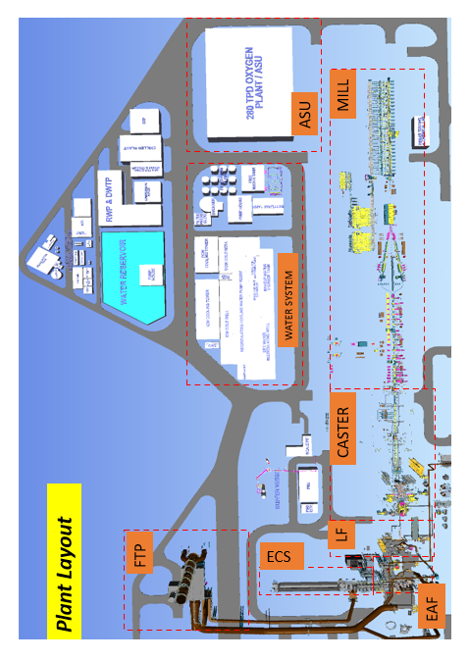

# TABLE OF CONTENTS

|  |
| --- |
| **CHAPTER 1 INTRODUCTION**   * 1. Motivation   2. Problem Statement   3. Work Plan   4. Expected outcome at the end of the project |
| **CHAPTER 2 LITERATURE**   * 1. Principle of operation   2. An overview of past work |
| **CHAPTER 3 SYSTEM DESIGN AND INTEGRATION**   * 1. UGV   2. UAV   3. Transformation |
| **CHAPTER 4 SIMULATIONS**   * 1. Transformation Mechanism (Showing the Transition Between UGV and UAV Modes)”   2. Complete UGV-UAV Transformer Model   3. Circuit Diagram Representation (Showing the Electrical and Control System Integration |
| **CONCLUSION** |
| **REFERENCES** |

**Chapter 1**

**INTRODUCTION**

## Motivation

The motivation for this project stems from the limitations of single-mode robotic systems and the growing need for adaptable autonomous solutions. Traditional UGVs struggle with obstacles,

while UAVs have limited battery life and payload capacity. A hybrid system that seamlessly transforms between ground and aerial movement offers a versatile and efficient alternative. Inspired by nature’s adaptive mobility—such as birds that run and fly—we sought to develop a cost-effective, dual-purpose robot that merges the advantages of both UGVs and UAVs. This

solution is particularly beneficial for agriculture, logistics, disaster response, and industrial inspection, where a single-mode system is inefficient.

Recent advancements in robotics, AI, and automation have made multi-modal systems more viable. We were driven by the technical challenge of designing a seamless transformation

mechanism, integrating mechanical design, aerodynamics, and power efficiency into a single, functional unit.

By developing this UGV-UAV Transformer, we aim to bridge the gap between ground and aerial mobility, creating a scalable and intelligent robotic system for real-world applications.

## Problem Statement

This project focuses on the design and development of a UGV-UAV Transformer, a robotic

system capable of seamlessly transitioning between ground and aerial modes. This hybrid system will integrate:

* + - A mechanical transformation mechanism enabling mode transition.
    - High-torque motors and actuators for stable UGV operation.
    - Quadcopter propulsion technology for controlled UAV functionality.
    - An optimized power and control system for efficient energy utilization.

## Work Plan

The development of the UGV-UAV Transformer was executed in a phase-wise manner, ensuring systematic design, fabrication, and testing. The plan was structured into three main phases, each focusing on different aspects of the project.

* + - **Phase 1**: UGV Assembly and Ground Mobility Testing
      * Objective:
        + Construct the UGV chassis and drivetrain to establish stable ground mobility.
        + Integrate and test DC motors, servo motors, and motor drivers.
        + Ensure structural stability and weight distribution for seamless transformation.
      * Components and Tasks:
        + Assemble UGV frame using carbon fiber and lightweight materials.
        + Install and configure BLDC motors, servo motors, and motor driver (L298N).
        + Program ESP-32 microcontroller for basic movement control.
        + Conduct torque and traction testing to validate ground mobility.
    - **Phase 2**: Transformation Mechanism and UAV Integration
      * Objective:
      * Implement the mechanical transformation system for mode switching.
      * Integrate linear actuators, servo motors, and locking mechanisms.
      * Assemble and test UAV propulsion (quad-propeller system).
    - Components and Tasks:
      * Attach linear actuators for transformation from UGV to UAV mode.
      * Install quad-propeller system and brushless motors for UAV mode.
      * Configure Electronic Speed Controllers (ESCs) and Flight Controller.
      * Conduct mode transition stability tests to ensure smooth transformation.
    - Perform flight stabilization tests for UAV functionality.
* **Phase 3**: Final Assembly, Testing, and Optimization
  + Objective:
    - Perform full-system integration of UGV and UAV functions.
    - Optimize control algorithms for seamless mode switching.
    - Conduct final performance evaluations and troubleshooting.
  + Tasks:
    - Optimize power management system for extended battery life.
    - Implement remote control functionality via a wireless receiver and remote controller.
    - Conduct real-world testing in different terrains to validate system performance.
    - Troubleshoot mechanical, electrical, and software issues.
    - Document final results and prepare project demonstration.

## Expected outcomes at the end of the project

* + - Successfully develop a working prototype of the UGV-UAV Transformer.
    - Achieve seamless transformation between UGV and UAV modes.
    - Validate mechanical integrity, aerodynamics, and power efficiency.
    - Demonstrate real-world applications in various industries

## Principle of Working

### Chapter 2 LITERATURE

* + - The UGV-UAV Transformer operates by integrating ground and aerial locomotion into a single robotic system. The primary principle behind its operation involves a seamless

transition between Unmanned Ground Vehicle (UGV) and Unmanned Aerial Vehicle (UAV) modes, enabling mobility across different terrains and obstacles. This is achieved through a mechanical transformation mechanism that repurposes components for both ground and aerial movement.

* + - In UGV mode, the robot utilizes high-torque motors and a stable chassis for ground mobility, allowing it to traverse rough terrain with precise control. The wheels or tracks provide

traction, while the onboard sensors facilitate navigation and obstacle avoidance. When aerial mobility is required, the system engages actuators and folding mechanisms to deploy

propellers, transitioning into UAV mode. Brushless motors and electronic speed controllers (ESCs) power the propellers, lifting the system off the ground for aerial operation.

* + - The transformation between UGV and UAV is achieved through a combination of linear actuators and servo motors that adjust the robot’s structural configuration. This design ensures minimal energy loss and optimal weight distribution, allowing efficient operation in both modes. Additionally, a centralized control system

manages power allocation, stability control, and mode transitions to ensure a seamless and autonomous transformation process.

## An overview of past work

* + - Research on hybrid UGV-UAV systems has gained significant traction in recent years, with various prototypes demonstrating multi-modal mobility. Some of them are mentioned below –

#### “Sihite, E., Kalantari, A., Nemovi, R. et al. Multi-Modal Mobility Morphobot (M4) with appendage repurposing for locomotion plasticity enhancement. Nat Commun 14, 3323 (2023).” – [link](https://www.nature.com/articles/s41467-023-39018-y)

* One of the notable works in this domain is the Multi-Modal Mobility Morphobot (M4) developed by Caltech. The M4 employs a unique appendage repurposing

strategy, allowing it to roll, crawl, crouch, and fly using the same set of actuators.

Inspired by biological models such as birds and quadrupeds, M4 showcases the potential of integrating multiple locomotion modes into a single platform.

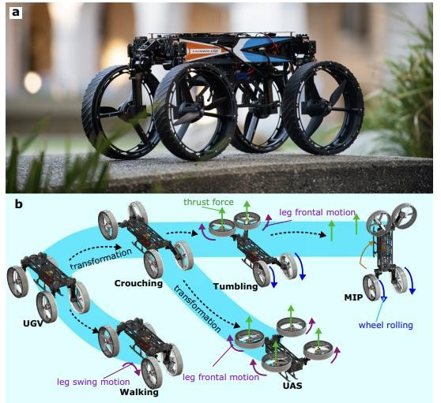

#### “{Chen}, Le and {Yu}, Jie and {Chen}, XingWu. et al. GuLu·XuanYuan , a biomimetic Transformer that intergrateshumanoid MIP, reptile UGV, and bird UAV.” – [link](https://arxiv.org/abs/2404.09822)

* This article proposes a multi habitat bio-mimetic robot, named as GuLu XuanYuan.It combines all common types of mobile robots, namely humanoid MIP, unmanned ground vehicle, and unmanned aerial vehicle. These 3 modals imitate

human, bird, and reptile, separately. As a transformer, GuLu XuanYuan can transform from one modal to another. Transforming function integrates the

specialized abilities of three robots into the same machine body. This simplification approach helps to reduce the total number of required robots. From another

perspective, the deformation function is equivalent to creating more economic value.

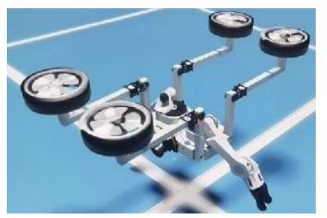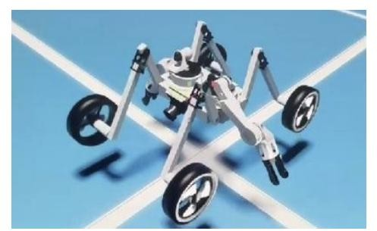

1. ***“Michael Rechtin, A.A. (2024, November 18). Building a Real Life Transformer [Video]. YouTube” –*** [***link***](https://www.youtube.com/watch?v=f1GSzysrYtw)

* This video presents a practical implementation of a UGV-UAV transformation system, offering insights into mechanical design considerations, power

optimization, and feasibility assessments.

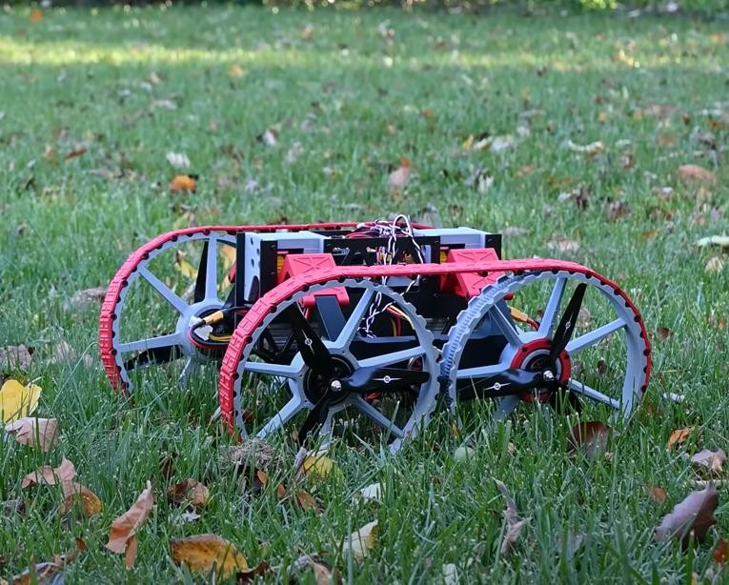

## Chapter 3

**SYSTEM DESIGN AND INTEGRATION**

In this chapter, we present a comprehensive account of the physical realization of the UGV-UAV Transformer. The complexity of this system lies not only in its individual subsystems but more importantly in the seamless integration of these distinct modules into a single, coherent, and functional unit.

This chapter is structured into three detailed subsections, each focusing on a core segment of the system:

* The **UGV subsystem**, which forms the structural and locomotion backbone on the ground.
* The **UAV subsystem**, which enables vertical take-off, controlled flight, and aerial stability.
* The **Transformation mechanism**, which serves as the critical link between modes, allowing structural reconfiguration at runtime without compromising system integrity.

## UGV

The Unmanned Ground Vehicle (UGV) module serves as the foundational locomotion unit of the hybrid transformer system. It is designed to operate effectively over rugged terrain and provide a stable base for take-off and landing in UAV mode. The UGV’s structural design prioritizes **mechanical robustness, torque-optimized mobility, and lightweight construction**, ensuring reliable operation even under variable loads and transformation-induced stresses.

To achieve this, the UGV incorporates **high-torque BLDC motors** that drive the rear wheels through a geared transmission system. The selected motors (IDUINO 5010-360KV) are capable of delivering a post-gearing torque of 3.41 Nm, thus ensuring that the vehicle can overcome resistive forces and surface friction.

The UGV’s frame has been fabricated using **acrylic sheets**, chosen for their strength-to-weight ratio and structural rigidity. Lightweight yet durable, the frame supports not only the locomotion elements but also houses the transformation system and UAV propulsion components without compromising maneuverability.

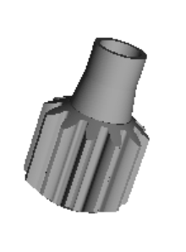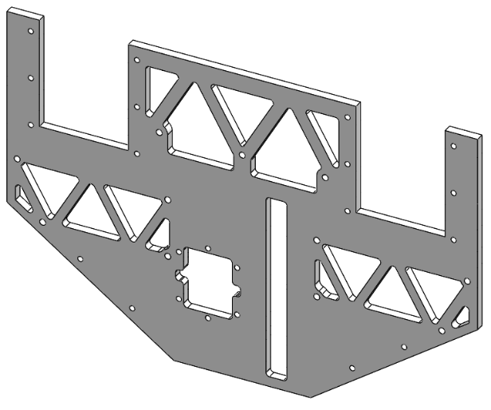

Side Plate Motor Gear

The **motor driver (L298N)** interfaces with an **ESP32 microcontroller**, which handles PWM-based speed regulation, direction control, and wireless communication.

The UGV is controlled via a multi-channel PWM signal system, where four channels are assigned to different subsystems. These signals are received through a dedicated receiver and interpreted by the onboard **ESP32 microcontroller**, which serves as the local control hub for the UGV. The ESP32 then reads the PWM values from **four active channels** and converts them into appropriate control commands for the wheel motors, steering logic, servo-driven linkages, and DC-powered linear actuators. The PWM signal's pulse width varies between 1 ms (minimum) and 2 ms (maximum), representing the desired control level for each actuator. This setup provides precise, real-time remote control over both locomotion and transformation functions.

The differential drive control strategy allows the UGV to perform turning maneuvers smoothly. **3D printed wheels**, optimized for weight and traction, form the contact interface with the ground and were customized using PLA to match both the mechanical profile and aesthetic integration of the overall system.

SolidWorks Model of the wheel 3D Printed Wheel

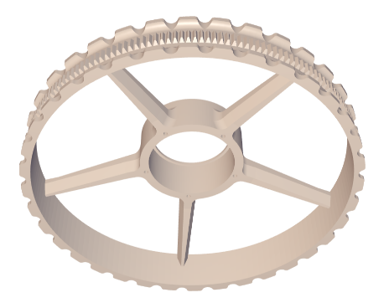

Collectively, the UGV subsystem functions as a rugged ground mobility platform, offering precision control, power efficiency, and structural versatility, while also serving as the mechanical scaffold for the aerial system.

**UAV**

The UAV subsystem is designed to provide **vertical lift, aerial navigation, and hover stabilization**, extending the operational scope of the robot beyond what terrestrial mobility can achieve. This capability is essential for applications in environments with **terrain discontinuities, elevation changes, or inaccessible regions**, where flight becomes the only viable mobility option.

At the heart of the UAV module are **four 2215 1100KV brushless motors**, mounted inside the rotor arms of the transformer. These motors offer a high thrust-to-weight ratio, capable of lifting the entire integrated structure with enough margin to account for battery drain and aerodynamic drag. The KV rating (RPM per volt) of 1100 strikes a balance between lift force and current draw, ensuring energy-efficient flight.

Each motor is paired with **8045 propellers**, chosen for their aerodynamic performance and compatibility with the motor shaft specifications.



To reduce wiring complexity and increase synchronization during high-speed operations, we employed **a 4-in-1 Electronic Speed Controller (ORION 35A.**

The **4-in-1 ESC** consolidates the function of four individual ESCs into a single, compact board. Each channel of the ESC independently controls a brushless motor by generating **precise PWM or DSHOT signals** based on input from the flight controller. It regulates voltage and current to the motors, ensuring that they spin at the desired RPM based on throttle commands, while also providing **telemetry feedback** (e.g., temperature, voltage, RPM) back to the flight controller. This real-time motor feedback enables more accurate control and advanced flight features like **current limiting and dynamic braking**. The compact integration of four motor controllers in a single PCB not only saves space but also improves heat dissipation and electromagnetic compatibility. Our ESC supports **continuous current ratings of up to 35A per channel**, with bursts of up to 40A, which is more than sufficient for our 2215 1100KV motors driving 8045 propellers. Additionally, the use of a 4-in-1 ESC eliminates the complexity of synchronizing separate ESCs, ensuring all motors respond uniformly, thus enhancing **stability during hover and rapid transitions**. The board is mounted directly beneath the flight controller in a stack configuration, with **BLHeli_S firmware** for easy configuration via Betaflight passthrough.

Central flight control is managed by a dedicated **flight controller (SpeedyBee F405 V3)**, equipped with an Inertial Measurement Unit (IMU) for dynamic orientation sensing and onboard stabilization algorithms.

The **Speedybee F405 V3** is a high-performance flight controller built on the **STM32F405** microcontroller, offering fast processing capabilities, low-latency signal handling, and extensive connectivity options. It integrates a **6-axis IMU**, **barometer**, **OSD**, and **blackbox logging**, all of which are essential for maintaining stable flight and for post-flight analysis.

* **6-axis IMU:** The 6-axis IMU is a sensor module that combines a **3-axis gyroscope** (measuring angular velocity) and a **3-axis accelerometer** (measuring linear acceleration). It allows the flight controller to determine the drone’s **orientation** (roll, pitch, yaw) and detect changes in motion. This real-time motion sensing is essential for maintaining flight stability, executing smooth maneuvers, and recovering from disturbances during flight or transformation.
* **Barometer:** The barometer measures **atmospheric pressure** to estimate the drone’s altitude above sea level. It enables features like **altitude hold**, smoother takeoff/landing, and height-based navigation. Unlike GPS, the barometer provides fast and fine-grained altitude feedback, which is especially important for low-altitude hovering and indoor flight stability.
* **OSD (On-Screen Display):** The On-Screen Display overlays critical flight data (battery voltage, altitude, flight time, RSSI, etc.) onto the FPV (first-person view) camera feed. This lets the pilot monitor real-time telemetry without needing separate ground station equipment, improving situational awareness and safety during manual control or testing.
* **Blackbox Logging:** Blackbox logging records real-time flight data such as gyro readings, PID outputs, motor responses, and receiver inputs. This data can be reviewed post-flight to analyze performance, identify causes of instability, or fine-tune PID gains. It is a powerful tool for debugging complex behaviors, especially during mode transitions and dynamic transformations.

The controller is compatible with **Betaflight** even though it has its own SpeedyBee Firmware, allowing extensive tuning of PID parameters, flight modes, and failsafe behavior. With its built-in support for **SBUS, UARTs, and PWM/DSHOT outputs**, it serves as the central node of the UAV's control system, interpreting signals from the receiver and sensors, and dynamically adjusting motor outputs to ensure precise stabilization in real-time. This controller also receives remote inputs via a telemetry receiver to allow manual override and flight path adjustments.

The **SBUS (Serial BUS)** signal is used to interface the receiver with the **Speedybee F405 V3** flight controller. SBUS is a digital serial protocol capable of carrying 16 channels of control data through a single wire, offering high signal resolution and low latency. This compact and efficient communication method is critical for reducing wiring clutter and ensuring reliable transmission of real-time control commands to the flight controller. The SBUS signal is decoded by the flight controller and used to update motor outputs via the ESC, enabling precise multirotor control.

This aerial subsystem transforms the UGV into a fully functional quadcopter, making it capable of navigating vertically and laterally through the air, providing critical enhancements in speed, adaptability, and reach.

**Transformation**

The transformation subsystem lies at the heart of our hybrid robotic design, enabling the vehicle to dynamically shift between its UGV and UAV configurations. The primary components facilitating this transformation are **two high-torque servo motors** and **two linear actuators**, which work in tandem to reposition the UAV rotor arms from a stowed ground configuration to a flight-ready state. Upon receiving PWM signals from the transmitter (via the ESP32), the servo motors initiate the transformation by **lifting the central rotor arms** upward. These servo motors are rated at **25 kg·cm**, providing sufficient torque to overcome gravitational and structural resistance during lifting.

Once the arms reach their threshold angle, the **linear actuators** extend forward to **lock the rotor arms into their final position**, providing rigid structural support for stable quadcopter operation. Each actuator features a **stroke length of 100 mm** and a thrust force capacity of approximately **60 N**, ensuring the system remains stable even under vibration or wind disturbances during flight. This two-stage transformation—first rotational via servos, then translational via actuators—ensures smooth, coordinated motion without causing imbalance or stress on the frame.

In order to transition from ground mode to flight mode, a **mode-switching step is also performed on the receiver**. The receiver, initially operating in **PWM mode for UGV control**, must be switched to **SBUS mode** to interface with the **Speedybee F405 V3** flight controller. This is achieved by enabling **binding mode** on the transmitter and re-binding the receiver to configure it for SBUS output. This change allows the UAV to receive high-speed, multiplexed control data required for flight stabilization and precise motor control via the flight controller. The entire transformation—both mechanical and signal-level—occurs wirelessly and in real time, enabling the robot to adapt seamlessly to operational demands.

|  |
| --- |
| Brushless motor (x4) |
| Servo Motor(x2) |
| DC Motor(x2) |
| Linear Actuator(x2) |
| LiPo battery(x1) |
| Flight Controller |
| ESCs (4 in 1) |
| Motor Driver(x1) |
| Voltage regulators |
| ESP 32 |
| Propellers(x4) |
| Carbon Fiber sheet |
| Wires, Remote Controller |
| ABS |

The selection of components was guided by performance requirements, weight constraints, and energy efficiency considerations. Below are the justifications for the key components:

### Brushless Motors (2215, 1100KV, x4)

* Selected for high thrust-to-weight ratio essential for UAV flight.
* KV rating ensures balanced speed and torque, optimizing power efficiency.
* Compatible with ESCs and Flight Controller, ensuring smooth aerial transitions.

### Servo Motors (25KG High Torque, x2)

* Chosen for high torque output, necessary for lifting the center body during transformation.Full metal gears and waterproof design ensure durability and reliability.
* Torque calculations confirm adequate lifting capacity:
* With two motors, total lifting capacity is 3.84 kg, sufficient for structural transformation.

### DC Motors (IDUINO 5010-360KV, x2)

* Provide high torque for efficient UGV operation.
* 360KV rating ensures an optimal balance between speed and power consumption.
* Estimated torque of 3.41 Nm after gear transmission, exceeding the required 0.098 Nm per wheel.

### Linear Actuators (x2)

* Essential for seamless mechanical transformation between UGV and UAV modes.
* Load capacity of ~60 N, ensuring resistance to turbulence and structural stability.
* Stroke length of 100 mm, allowing for controlled movement and deployment.

### LiPo Battery (4S, 14.8V, x1)

* Provides high discharge rates, ensuring sufficient power for both UGV and UAV operation.
* Compatible with ESCs, motors, and actuators, ensuring smooth power delivery.

### Flight Controller

* Regulates aerial stability and manoeuvrability.
* Works with IMU sensors to optimize UAV navigation.

### ESCs (4-in-1, ORION 35A)

* Chosen for efficient motor speed regulation in UAV mode.
* Provides stable current flow, minimizing power losses.

### Motor Driver (L298N, x1)

* Controls DC motor operation in UGV mode.
* Ensures precise movement control and power efficiency.

### ESP-32 (Microcontroller)

* Provides wireless communication for remote operation.
* Handles real-time data processing and system control.

### Structural Materials (Carbon Fiber, ABS, Wires)

* Carbon fiber ensures lightweight yet strong structural support.
* ABS material used for protective casing and housing.
* Wires and connectors ensure efficient power transmission and signal communication.

**3D Printed Wheel -**

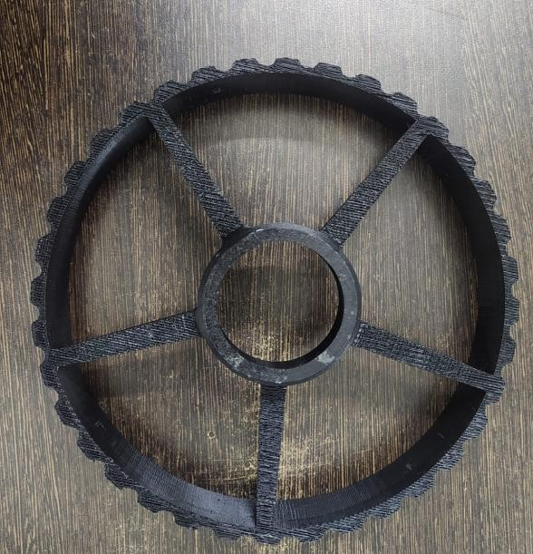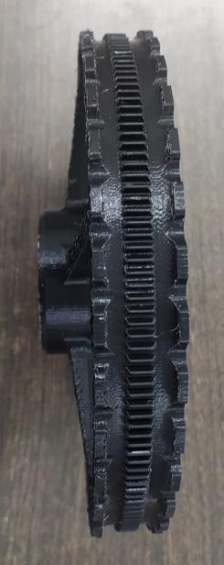

## Chapter 4 SIMULATIONS

*“Transformation Mechanism (Showing the Transition Between UGV and UAV Modes)”*

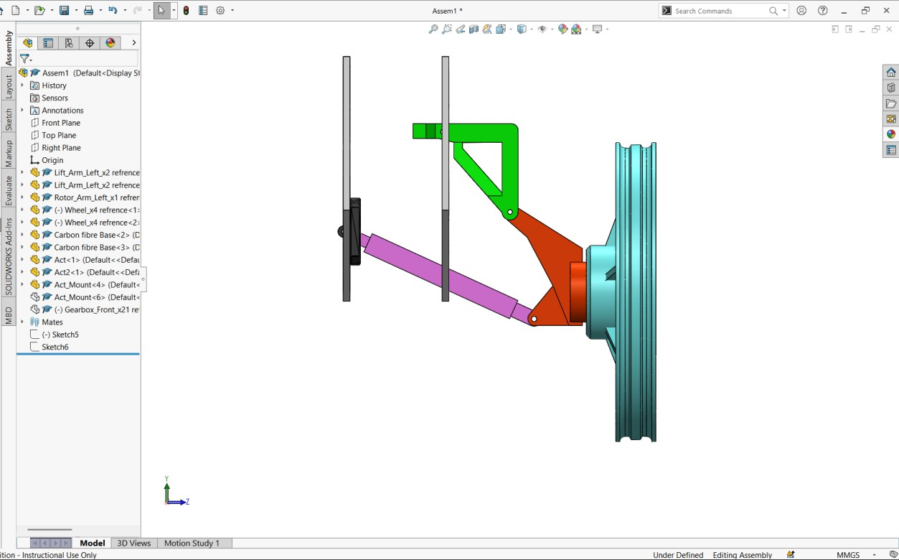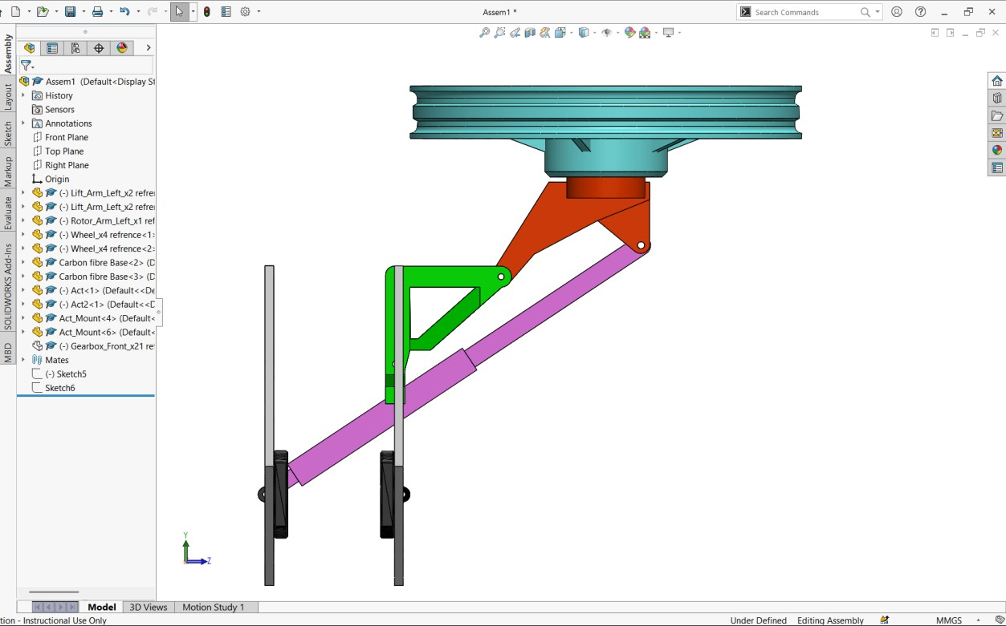

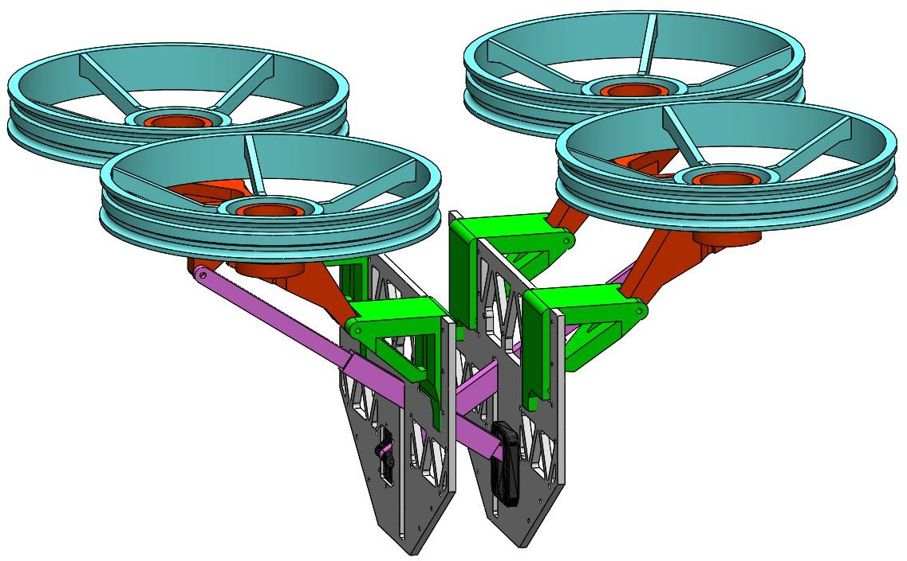

*“Complete UGV-UAV Transformer Model”*

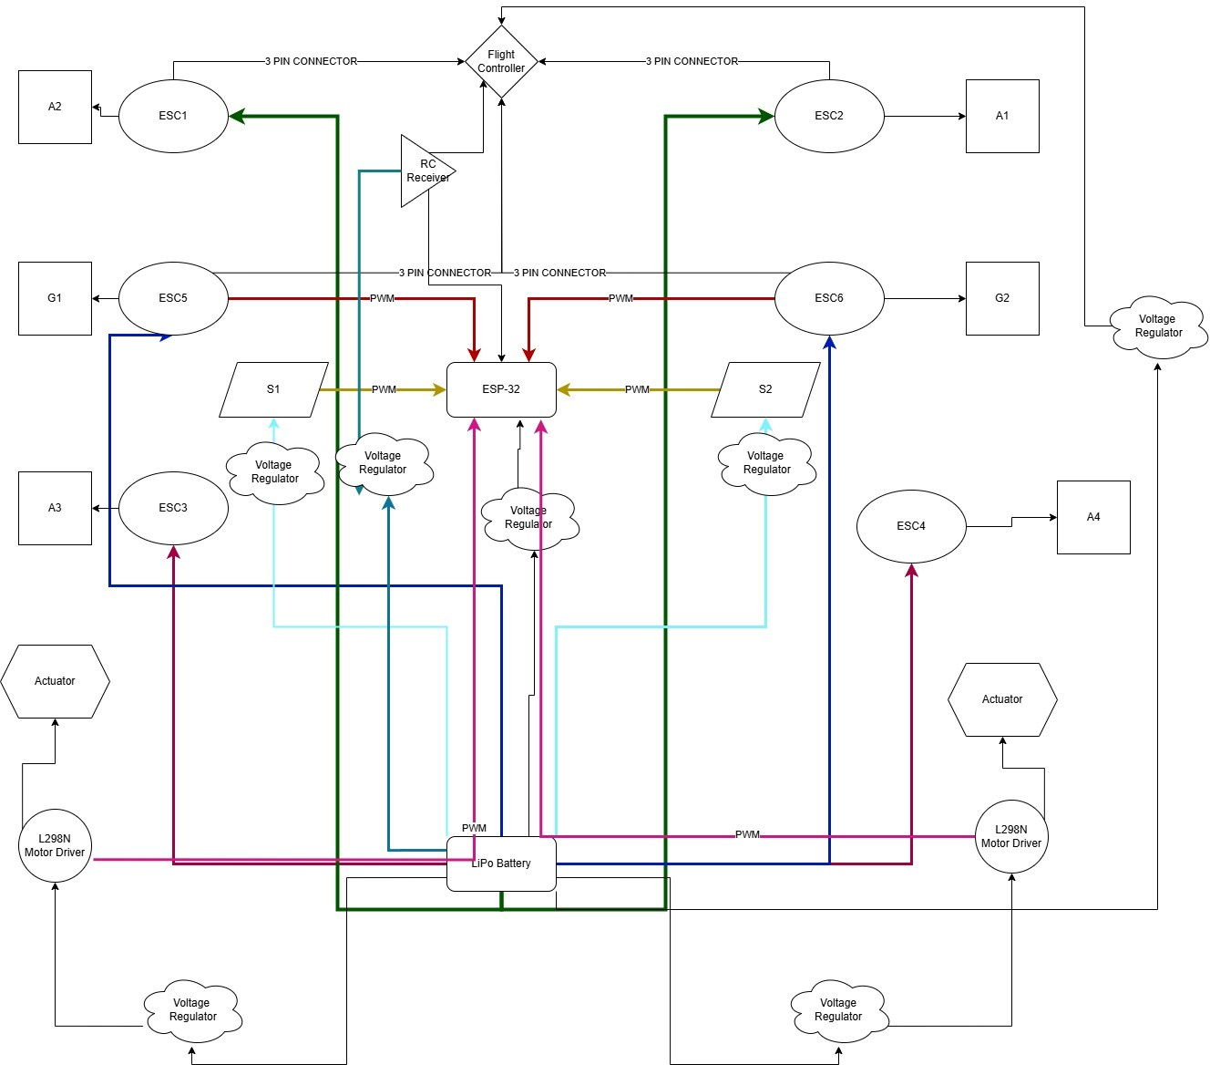

*“Circuit Diagram Representation (Showing the Electrical and Control System Integration)”*

## Conclusion

* The UGV-UAV Transformer project is an innovative approach to combining ground and aerial mobility in a single robotic system. This report covers the conceptual design, theoretical framework, component selection, and initial simulations, forming the foundation for prototype development. We have established the feasibility of a seamless transformation mechanism using linear actuators, servo motors, and BLDC motors. The integration of a microcontroller-based control system ensures smooth operation in both UGV and UAV modes.
* So far, we have completed the SolidWorks simulation, finalized component selection, and started fabricating the model. The 3D printing of structural parts has begun, with one wheel already completed. Moving forward, we will focus on completing the fabrication, assembling all mechanical and electronic components, and integrating the transformation mechanism. After assembly, we will conduct preliminary testing to evaluate both UGV and UAV functionality.
* As the project progresses, we aim to improve autonomy, optimize power efficiency, and enhance structural durability. With further refinements, this system has the potential to be used in various applications such as agriculture, logistics, industrial inspection, and disaster response.

## References

* *Michael Rechtin, A.A. (2024, November 18). Building a Real Life Transformer [Video]. YouTube.*
* *Sihite, E., Kalantari, A., Nemovi, R. et al. Multi-Modal Mobility Morphobot (M4) with appendage repurposing for locomotion plasticity enhancement. Nat Commun 14, 3323 (2023).*
* *“{Chen}, Le and {Yu}, Jie and {Chen}, XingWu. et al. GuLu·XuanYuan , a biomimetic Transformer that intergrateshumanoid MIP, reptile UGV, and bird UAV.”*